**Ethan Stancliffe**

My Style

* I am a pretty introverted guy unless I’m put around the people I know well and trust
* I have a very analytical mindset; creativity isn’t a big strength of mine though I often wish it was
* I have a ISTJ Myers-Briggs personality
* I enjoy playing video games, going hiking, and swimming
* My favorite color is purple

Values

* Genuineness
* Good work ethic
* Being fun
* Trustworthiness
* Respect
* Doing the dishes

No Patience For

* People who don’t respect me
* People who don’t wash their dishes and leave them in the sink for literal days on end
* Wyoming
* California gas prices
* Lazy people
* Annoying people

Communication

* My preferred method of communication with others is having a conversation face to face, getting straight to what they need from me, though email and text works fine too

How to Help Me

* Understanding who I am and how I work
* Giving constructive criticism when needed
* Giving me money
* Just being nice in general

Misunderstandings

* If I talk and you say, “Whoa, you talk?”, I do in fact talk, just not to you
* I am not a qualified IT guy just because I’ve been taking computer science classes for a couple weeks, no matter what my Mom says
* I’m not the most exciting guy, but I’m not as boring as people think
* I know it says 5’9” on my drivers license, but I’m actually 6’2”, there was just a rounding error at the DMV. If I ever seem short, it’s just a trick of the light.

**Chapter 2**

Health

Define: To me, health is a combination of not only physical health, but also mental, emotional, and social health; getting out and doing things with others and remaining balance is just as important to your health as eating and living healthy.

Measure: I think I am a pretty healthy guy for the most part. I live healthy, eat healthy (usually), and go out with friends almost every day. At BYUI, I am also happier than I have been for many, many years, so I am mentally healthy as well. I’d say I am at a 9/10, almost perfect but not quite since I don’t hit the gym as much as I should.

Analysis: As stated before, I feel very healthy almost all the time, and I think this is mostly due to the atmosphere of this campus; others have the same standards as me and lift me up, and I can really feel the spirit here, which I think plays a part in health as well.

Summary: It feels good to say that I am a healthy guy. That’s all I have to say here, because it really is that simple to me.

Work

Define: Work can be anything from labor you get paid for, any tasks you do for school or your job, or just simple acts of service you do for other people.

Measure: I work pretty hard when I am doing service, but otherwise I am a pretty laid back guy that procrastinates way harder than I should, which is in fact why I am turning this assignment in late. 5/10 for my work habits.

Analysis: I work harder when I am doing service for others because I care about them, and feel the actions I am taking have real effects on the lives of others and my own for doing this service, but often times in school or work, I feel like what I am doing is less important and only really affects me, so I can take the hit if I have to for procrastinating.

Summary: I value a hard work ethic, but I need to improve my own.

Play

Define: This involves taking time off your work to enjoy yourself and do things you want to do, spend time with family and friends, and just relax and have a good time.

Measure: As I stated above, I have a pretty bad work ethic, automatically making me good at this one. I may be a super outgoing guy that is always the life of the party, but I know how to kick back and do nothing well. 10/10 for this one.

Analysis: This is an important category to be good at, but you need to be able to balance this with work, as if you do one or the other, your life will never be the fullest it can be.

Summary: I am very good at Play and it is something I value in people, but it must be balanced with work.

Love

Define: Love is a hard one to define, since it can mean so many things; to me, it is something very important to you that you would do anything for, like family or close friends that you appreciate.

Measure: I think I have a lot of loved people in my life, and make time for all of them pretty well, so I’d say a solid 7/10 for me.

Analysis: I love my family and friends, and for the most part love the time I spend with them, so that’s why I rated my love what I did.

Summary: I have a lot of love to go around, but unfortunately the ladies do not seem to appreciate this yet. But at least my family and friends do.

Workview Compass

To me, work I do in the workplace that I am passionate about is extremely important, and I believe it should be to everyone who applied to work in the same field. It shouldn’t just be working to get paid, but rather something you are passionate about that just so happens to also be your main source of income. I feel like it’s too often people just think about the money to be made and don’t actually consider their interests when they are considering careers for themselves. If they took a moment to really think about what they wanted to do and committed to doing it, they would not only be doing what makes them happy, but also making money off of it. This would change views of the workplace from just another day of monotony to excitement about what you get to do that day.

Good Time Journal Entries

| **Activity** | **Engagement** | **Energy** | **Flow** |
| --- | --- | --- | --- |
| Ropes Course | High | High | Scary |
| Gym | High | High | Gym |
| Tetons | Medium | High | Beautiful |
| First Friday | Medium | High | Fun |
| Country Dancing | High | Medium | More intense than it needed to be |
| Rodeo | High | Low | Cool to watch |
| Tetonia Trail | Medium | Medium | Beautiful |
| Mesa Falls | Medium | Medium | Beautiful |
| Movie Night | High | Low | Chill |
| Game Night | Medium | High | Competitive |

3 Mind Maps

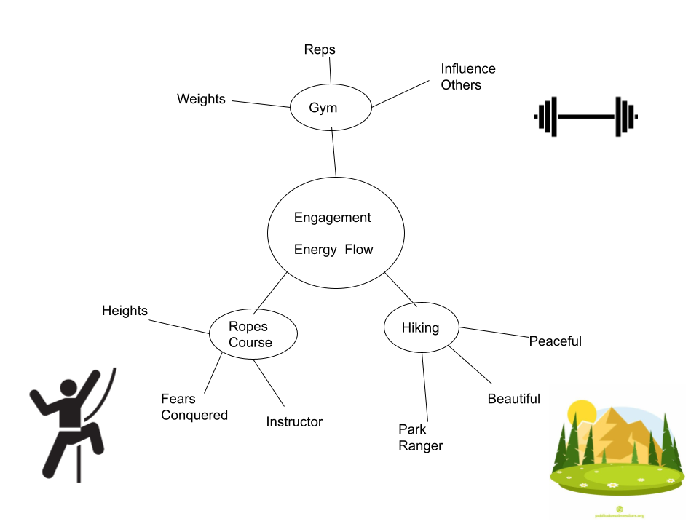

Odyssey Plans

A = Current Plan

B = Current plan, but add in a girlfriend

C = Plan without college

Year 1 Year 2 Year 3 Year 4 Year 5

| A. Finish the semester with passing grades | Mission | Mission | Go back to college, get all my generals out of the way | Focus on my degree |
| --- | --- | --- | --- | --- |
| B. Same as A | Mission | Mission | Go back to school, maybe get married | My main focus is now my family and providing for them |
| C. Work at Walmart | Become Team Lead | Become a Coach | Climb the ladder | Own a store, make bank |